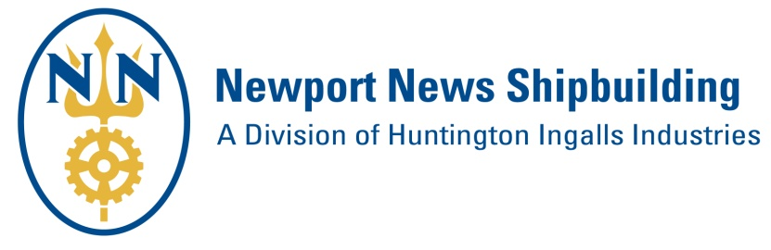
PROSPECTIVE SUPPLIER FORM
Please complete and return the form, and any marketing material (line card, capabilities sheet, etc.) to:
NNSProspectiveSupplier@hii-nns.com

Due to the volume of submittals, please allow 60 days for information review and onboarding decisions.

Form Submittal Date:

Contact Information
Company Name:
Street Address:
City: |  |  |  |  |  |  | State: |  |  |  |  | Zip Code:
Website:
Point of Contact Name: |  |  |  |  |  |  |  |  |  | Title:
Phone: |  |  |  |  |  | Email

Business Identification (Complete all that apply to your company)
NNS Supplier Number |  |  | DUNS Number
Cage Code |  |  | JCP Number

Have you been in contact with any personnel from NNS? Please list them below.
Name | Email | Phone

Business Type (“X” all that apply)
 | Manufacturer |  | Distributor |  | Service Provider

NAICS Code (http://www.census.gov/eos/www/naics/)
Primary NAICS # |  | Description
Secondary NAICS # |  | Description

Business Size
 | Large Business |  | Small Business

If Small Business is selected above, “X” all small business categories below that apply to your company:
 | Small Business Only |  | Women-Owned Small Business
 | Veteran-Owned Small Business |  | Service-Disabled Veteran-Owned Small Business
 | HUBZone Small Business |  | Economically Disadvantaged Women-Owned Small Business
 | Small Disadvantaged Business |  | Other:

NNS Buying Office Alignment for Supplier Onboarding Consideration
“X” the Buying Office(s) below that align with your company’s products/services.
Shipboard Products/Services
Office A – Procures raw material commodity items; metals, steel plate and shapes, bar, angle, pipe, small electrical components, fasteners, paint, coatings, insulation, hose, hose fittings, abrasives, adhesives, lumber, textiles, chemicals and compounds, rigging material, safety equipment, tape, tools, hardware, bottles and cylinders.
Office B – Procures - Valves, Fittings, Filters and Strainers.
Office C – Procures complex machinery for all programs, including main turbine generators, main reduction gears, High Pressure/Low Pressure turbines, oxygen/nitrogen plants, elevators, hoists, cranes, galley and medical equipment, heating/cooling systems, compressors, motors, pumps, condensers, scrubbers and burners, actuators, windows, complex bearings, precipitators, diesel generators, array systems and sanitation systems.
Office E – Procures complex electrical components and commodities such as Load Centers, Switchboards, Circuit Breakers, Waveguide, Controllers, Fire Detection Systems, Heaters, Degaussing Components, Communication Equipment (no telephones), and Solid State Frequency Converters.
Office H – Build to print fabrication, make/buy, shipboard subcontracting materials, parts, components, supplies and finished goods. (Sources, purchases, plans, and schedules the movement of Subcontracting materials, parts, components, supplies, finished goods and related material through production and inventory process.)
Office L - Outsourcing commodities: Machine Shop/Sheet Metal/Powder Coat & Coatings, Rolling/Forming/Fab/Plate Flattening and Large Structural Assemblies.
Build to print commodities include Shafting, Forging, Air Flaks, Built-Up-tees, Sea Chests, Water Tight Doors, Torpedo Tube Assemblies, and Fixtures
Office W - Shipboard subcontract services, leased labor, consulting, engineering services, testing, IRAD (Internal research & development) & CRAD (Customer research & development).

Commercial Products/Services (For NNS Facilities Support)
Office D-1 – IT (Hardware, Software & Services)
Office D-2 – Maintenance Repair Operations, Construction, Engineering and Facilities Services
Office D-3 - Business Services

Huntington Ingalls Industries Information (“X” all HII entities that your company is a current supplier)
 | Ingalls Shipbuilding |  | AMSEC
 | Continental Maritime of San Diego |  | Newport News Industrial (NNI)
 | Stoller Newport News Nuclear (SN3) |  | Universal Pegasus International
 | Undersea Solutions Group |  | None

Do you grant permission for this form and any other material you provided to be submitted to other Huntington Ingalls Industries entities that your company is not a current supplier? |  | Yes |  | No

Briefly list below your company’s products/services.

List below any Defense Industry companies that your company is a current supplier.

List below your company’s competitors.

If a follow up 30 minute Meet & Greet is desired by a Buying Office, “X” your company’s preferred method:
 | Teleconference |  | Face to Face at NNS in Newport News, VA (All attendees must be US Citizens)

