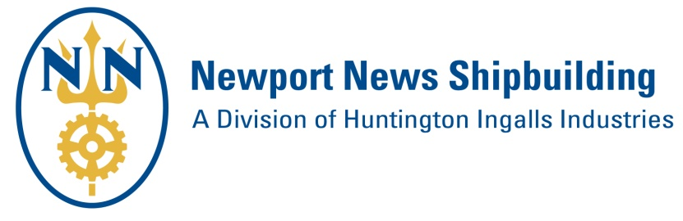
PROSPECTIVE SUPPLIER FORM
Please complete and return the form, and any marketing material (line card, capabilities sheet, etc.) to:
NNSProspectiveSupplier@hii-nns.com

Due to the volume of submittals, please allow 60 days for information review and onboarding decisions.

Form Submittal Date:

Contact Information
Company Name:
Street Address:
City: |  |  |  |  |  |  | State: |  |  |  |  | Zip Code:
Website:
Point of Contact Name: |  |  |  |  |  |  |  |  |  | Title:
Phone: |  |  |  |  |  | Email

Business Type (“X” all that apply)
 | Manufacturer |  | Distributor |  | Service Provider

North American Industry Classification System (NAICS) Codes and Business Size
If unknown, visit official NAICS website to find your NAICS codes, then use the SBA Size Standards Tool to determine your business size.
NAICS Code
Primary NAICS # |  | Description
Secondary NAICS # |  | Description

Business Size
 | Large Business |  | Small Business

If Small Business is selected above, “X” all small business categories below that apply to your company:
 | Small Business Only |  | Women-Owned Small Business
 | Veteran-Owned Small Business |  | Service-Disabled Veteran-Owned Small Business
 | HUBZone Small Business |  | Economically Disadvantaged Women-Owned Small Business
 | Small Disadvantaged Business |  | Other:

Huntington Ingalls Industries Information (“X” all HII entities that your company is a current supplier)
 | Ingalls Shipbuilding |  | AMSEC
 | Continental Maritime of San Diego |  | Newport News Industrial (NNI)
 | Stoller Newport News Nuclear (SN3) |  | UniversalPegasus International
 | Undersea Solutions Group |  | None

Briefly list below your company’s products/services.

List below any Defense Industry companies that your company is a current supplier.

List below your company’s competitors.

NNS Buying Office Alignment for Supplier Onboarding Consideration
“X” the Buying Office(s) below that align with your company’s products/services.
Shipboard Products/Services
Office A – Raw Metals, Steel Plate and Shapes, Bar, Angle, Pipe, Fasteners, Pipe Fittings, Hose Fittings, Paint, Coatings, Insulation, Abrasives, Adhesives, Lumber, Textiles, Chemicals and Compounds, Rigging Material, Safety Equipment, Tape, Tools, Hardware, Bottles and Cylinders
Office B – Valves, Filters, Strainers, and Actuators
Office C – Complex and Deck Machinery Components; Habitability (Pumps, Hoist and other Lifting Equipment, Davits, HVAC Fans, Galley Equipment, Dental Equipment, etc.)
Office E – Complex Electrical Components and Commodities such as Load Centers, Switchgear, Cable, Waveguide, Controllers, Fire Detection Systems, Heaters, Cable Racks, Gages, Meters, Transducers, Transmitters, Degaussing Components, Power Supplies, Communication Equipment, Solid State Frequency Converters, and Onboard Repair Parts
Office H –Build to Print Fabrication, Make/Buy, Shipboard Subcontracting Materials, Parts, Components, Services, Supplies, Finished Goods and Engineering Services

Commercial Products/Services (For NNS Facilities Support)
Office D-1 – Business Services, IT (Hardware, Software & Services)
Office D-2 – Maintenance Repair Operations, Construction, Engineering and Facilities Services

If a follow up 30 minute Meet & Greet is desired by a Buying Office, “X” your company’s preferred method:
 | Teleconference |  | Face to Face at NNS in Newport News, VA (All attendees must be US Citizens)

Do you grant permission for this form and any other material you provided to be submitted to other Huntington Ingalls Industries entities that your company is not a current supplier? |  | Yes |  | No

