[](http://www.hii-homeport.com/hii/logos/nns_color_linetag.jpg)

**NNS Freight Routing Guide**

**Current as of January 9, 2015**

This routing guide provides direction to Newport News Shipbuilding (NNS) suppliers on shipment of material from the supplier’s location to NNS facilities and other purchase order related shipments.

**Unless explicitly authorized and agreed to by the NNS Traffic Office, the supplier is required to follow the instructions listed within this routing guide.** Not following this guide such as using unapproved carriers, not completing Bill of Lading as directed (include PO and Item Number), not using Lane Balance for shipment and delivery scheduling, and not including required bar**-**coding on the shipping label can result in the vendor being billed for the freight charges and/or negative impact on invoice payments for the provided material. Appendix A, NNS Supplement to PO is the contract reference to this document.

1. **NNS Contacts:**

**A.1 NNS Traffic Office Contacts:**

**(800) 426-1910 email:** [**NNSTrafficOffice@hii-nns.com**](mailto:NNSTrafficOffice@hii-nns.com)

**(757) 380-4062**

**(757) 688-8493 (Fax)**

**A.2 NNS Receiving Contacts:**

**(757) 688-0712 email:** [**O53ReceivingMailbox@hii-nns.com**](mailto:O53ReceivingMailbox@hii-nns.com)

**(757) 897-2675**

**(757) 688-3720(Fax)**

**A.3 Lane Balance Contacts:**

**(888) 690-8885 email:** [**nnstransportation@lanebalance.com**](mailto:nnstransportation@lanebalance.com)

**(901) 759-2926 (Fax) Website:** [**www.lanebalancesmc.com**](http://www.lanebalancesmc.com)

**A.4 NNS Buyers**

NNS buyer names and contact information is located on the front page of the NNS Purchase Order.

1. **Shipments Sent by Ground:**

**B.1 - Shipments 150 lbs or less:**

Shipments 150 lbs or less shall be shipped via FedEx Ground.

Follow the following instructions when setting up shipments via FedEx:

***Paper/Hardcopy Form:***

It is **MANDATORY** that the NNS PO number and item number be included on the FedEx form if the shipment is PO related. If not PO related it must include an appropriate NNS charge. Include in the “Your Internal Billing Reference” field.

The Purchase Order (PO) and PO Line Item Numbers must appear as a PO Number/Item Number, no spaces, dashes, alpha characters, or leading zeros. (Ex 4500012345/2)

If more than one PO or PO line item is being shipped they must be shipped individually with individual Bill of Lading’s.

PO Numbers must always be NNS PO numbers not your internal numbers or third party PO numbers. The PO and PO Item Number allows NNS to allocate the freight charges appropriately.

If using a hardcopy form indicate the PO number as located below: 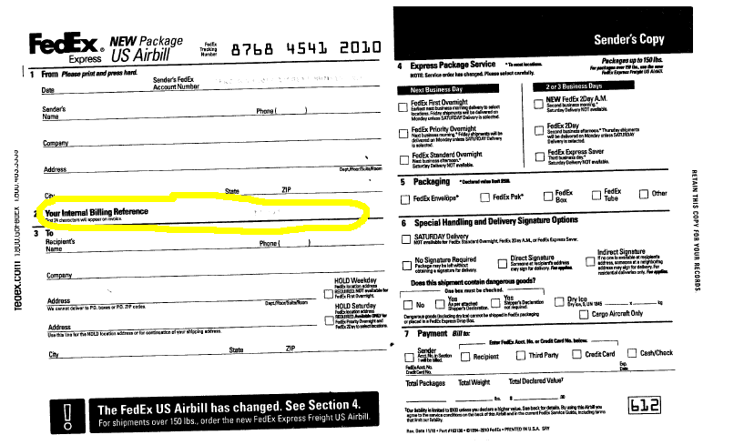

**PO and Item Number must be marked on this line. Example 4500384001/2 It is MANDATORY that you mark the A/B with the PO and item number as shown in the example or the shipment may be rejected**

In the “Payment Bill to” area indicated “recipient” and indicate Newport News Shipbuilding.

***Online/FedEx Website:***

If using online FedEx programs include the required PO and Item Numbers in the “***Your Reference***” area of the online program.

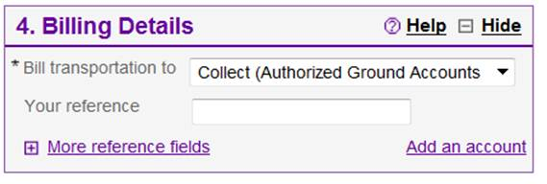

Click on “***More reference fields***” and enter the PO information in “***P.O. no.***” field.

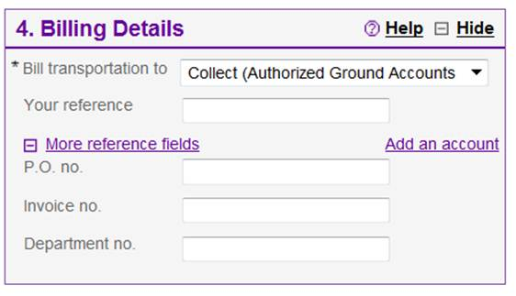

**MANDATORY – Add PO/Item number in this filed or NNS charge if not a PO related shipment.**

Do not include “PO”,“#”, or any other text in the fields. Only include the numbers and “/”.

In the “Billing Details” section under “Bill Transportation to” select “Collect”. At delivery of material to NNS FedEx will scan a bar-code associated with our account so as to charge properly to NNS.

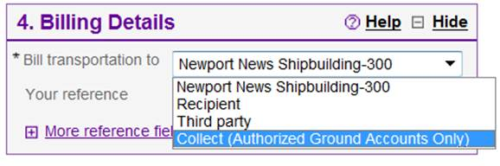

**B.2 – Shipments greater than 150 lbs:**

NNS suppliers must contact Lane Balance (contact info above) to setup appropriate domestic shipments unless otherwise specified in the PO. This is a **mandatory** requirement. It includes partial and full truckload shipments. Lane Balance will select the correct NNS contracted carrier and schedule pickup at your facility and delivery to NNS.

If you ship more than one or two shipments to NNS you must obtain a password for access to the Lane Balance system to enter your shipment information. For infrequent shipments to NNS you can contact them directly and provide them the necessary information for shipment.

Once you request initial access to the Lane Balance system you will be asked to setup a company profile. This will include the following attributes:

* + Company Name
  + Address (or addresses)
  + Hours of shipping operation
  + Contact information
  + Dock or loading area information
  + Any other special information regarding your pickup location and process

You will also be able to track your shipment via the Lane Balance system.

Training for use of the system is located at on the NNS Traffic website noted above.

**B.3 – International Shipments:**

Contact the NNS Traffic Office for all international shipments so that we can validate all necessary Import/Export processes are followed correctly. Given the complexities in setting these shipments up as much advanced notice of the shipment as possible is desired.

**B.4 – Air Freight:**

Air Freight is only to be used when explicit instructions to do so are given by an authorized NNS Representative. If authorized, for letters and packages up to 150 lbs use FedEx (ship collect to NNS). All air freight above 150 lbs must be coordinated through the NNS Traffic Office.

**B.5 – Shipments by Rail or Barge:**

For shipments by rail or barge contact the NNS Traffic Office.

**B.6 – Special Shipments:**

For very unique shipments some additional information regarding shipments may be included in your purchase order. In most cases these unique shipment (excess sizes or security sensitive shipments for example) should be coordinated with the NNS Traffic Office. Please notify NNS at least 3 weeks in advance of pickup since permits and special equipment may need to be obtained.

**B.7 – Third Party Shipments:**

Any third party shipments in support of NNS purchase orders would use the same guidance as noted here in for shipments to NNS. NNS requirements shall be passed onto all sub-tier suppliers. The use of Lane Balance and the requirements to bar-code must be conveyed to the sub-tier suppliers.

**B.8 – Deliveries by Suppliers utilizing their own trucks:**

If you are a supplier in the Hampton Roads area that intends to delivery material on your own truck it is **mandatory** that you contact Lane Balance to schedule a time slot for delivery when delivering to Main Receiving (other locations may add time slot scheduling in the future). Suppliers that deliver frequently can schedule standard times for each week in lieu of scheduling each timeslot individually. Contact Lane Balance to setup the standard periodic delivery times.

It is **mandatory** that you follow the shipping label/bar-coding and container marking as discussed in this document.

You must also either enter the information regarding the material to be delivered into the Lane Balance system or provide the required data to Lane Balance for entry.

**C – Freight Terms:**

C.1 – If the purchase order freight terms are FREIGHT COLLECT (most PO’s) the shipper must not ship PREPAID and ADD. NNS negotiated optimum rates with preferred carriers to lower the overall cost of freight to NNS and our customers. Shipping FREIGHT COLLECT is the means to take advantage of the optimum rates. If however it becomes necessary to ship PREPAID and ADD, the buyer will advise the supplier and will revise the purchase order to reflect the new terms. When freight rates have been prepaid and added by a supplier, NNS requires that a copy of the paid transportation bill accompany the supplier’s invoice.

C.2 – DO NOT SHIP COD. This means the carrier is to collect the cost of the material at time of delivery. This is never an accepted method of shipment.

**D – Shipping Labels/Bar-coding:**

Having shipping labels with proper bar-coding is key to effective and efficient receipt of materialat NNS. All material must be shipped to NNS with shipping labels with necessary bar-coding. This allows the material to be received quicker and with fewer errors positively impacting the invoice process. One of two methods may be used for appropriately bar-coded shipping labels. They are:

* Use of Lane Balance provided shipping label – When you setup a shipment with Lane Balance they will provide you a PDF of a shipping label and packing list with all the necessary fields in approved bar-code format.
* Use of your own shipping label – You can use your own shipping label if it contains all the necessary information with proper bar-code format and has been **approved by NNS**. Your shipping label must have the following information:
  + NNS PO number (make sure the number is not preceded with “PO”)
  + PO Item number (do not include leading zeros)
  + Quantity (do not include leading zeros)
  + NNS Part Number
  + Weight (do not include leading zeros)
  + The font should be industry standard code 128
  + The actual bar-code should not have the title of the information imbedded in the bar-code. For example the barcode would be “4500000000” not “PO Number 4500000000”. When extraneous information is in the bar-code the bar-code reader will not register the information correctly.

To obtain approval to use your shipping label provide a copy to NNS at[**O53ReceivingMailbox@hii-nns.com**](mailto:O53ReceivingMailbox@hii-nns.com)**.** NNS will validate the information is correct and test the bar-code on our readers. Upon approval from NNS you can use your shipping label in lieu of the Lane Balance one.

In addition the shipping label must be placed on the carton as shown below:

**Shipping label on front**

The shipping label may be on a label attached directly to the carton/container or in a pouch securely attached to the carton/container.

Lane Balance will also provide a packing slip with necessary bar-coding.

**E – Marking for multiple containers per PO line item:**

When shipping the same PO and line item in more than one container/carton/pallet you must mark each of them to indicate the quantity of items. For example 1 of 5, 2 of 5, etc. This helps prevent loss of material and or improper quantity receipt which can negatively impact invoice payment.

**F – Receiving Requirements for Material Shipped to Newport News Shipbuilding:**

Suppliers must abide by the following requirements for material deliveries to NNS. Failure to meet one or more of these requirements could be cause for shipment rejection and delayed payment.

* *Each shipment shall be in the form of containers (i.e. crates, boxes, or cartons) for unloading by a standard 4000-pound forklift truck to the greatest extent practical.*
* Each shipment shall include a separate, legible packing list for each PO Item number of each NNS Purchase Order (PO) that has material included in the shipment.
* Different PO Item numbers shall not be comingled in containers.
* Multiple containers associated with one packing list shall be numbered, marked or labeled to facilitate receipt verification of all shipped containers. For example, when all of the material on one packing list is contained in three containers, mark or label the containers 1 of 3, 2 of 3, and 3 of 3.
* Two copies of each packing list shall be provided, one attached to the outside of the number 1 container and the other packed inside the same container along with any additional paperwork when such paperwork is required to be provided with the shipment by the NNS PO (e.g., certifications, test reports, etc.). For a shipment of material that has been source inspected by NNS, a copy of the Source Inspection Report (SIR) shall be attached to the copy of the packing list packed inside the container. The inner packing list and all accompanying paperwork shall be easily accessible once the container is opened. For non-containerized material, the unit with the packing list shall include an enclosure that is attached to the unit or the units shipping fixture (e.g., pallet or skid), with one packing list attached to the outside of the enclosure and the other copy of the packing list and additional paperwork inside the enclosure.
* *Use of yellow wrapping material or attached yellow protection devices such as caps or plugs is prohibited.*
* Unless prior approval is obtained, do not ship material for a PO Item number in excess of the total NNS PO quantity for that PO Item.
* Note that your purchase order may contain additional requirements regarding shipment of material.

**F – Loading requirements for Raw Product Material Shipments to NNS**

1. Load must be separated from the bed or deck of the truck or trailer by a minimum of 3.5 inches (ex: a 4” x 4” post) to allow for use of NNS forklift and / or rigging gear. The load must be set so that it can be picked up by a forklift from any side.
2. The bed or deck of the truck or trailer must be no higher than 5 feet from the ground.
3. The maximum height of all material loaded on the truck or trailer must be no more than 5 feet from the bed or deck of the truck. No material will be off-loaded requiring the fork of the forklift to be raised higher than 5 feet from the bed or deck of the truck or trailer.
4. The CG (center of gravity) must be identified for all crates and pallets where the CG is not readily visible and immediately obvious to the NNS forklift driver.



1. All palletized raw products must be banded with a steel band specified for the appropriate weight in accordance with the strength of the pallet.
2. All raw products must be segregated by warehouse destination to help facilitate offloading. Listing of part numbers by warehouse can be obtained from NNS.
3. All truck drivers are responsible for securing their load before moving on to the next stop in NNS.
4. The maximum weight of any individual bundle, pallet or crate containing raw stock is 4,000 lbs (2 short tons). Any shipment in excess of that amount must be coordinated through the NNS Traffic office.
5. Ensure that if a bundle, crate, or pallet contains sizes that are not of a uniform length, that the longer lengths are placed on the bottom and the shorter lengths are on top.
6. All trucks and trailers delivering material to NNS must be safe and in good repair. There must be no holes, etc. in the bed or deck of the truck or trailer. Vehicles deemed to not be safe, at the discretion of NNS, will not be allowed entry to our facilities.
7. Improper loading for delivery to NNS may be cause for refusal and if shipping cost is paid by NNS, then a charge-back against the supplier will be taken for any additional costs incurred in unloading or reshipment.

**G – Raw Product Delivery Location/Hours:**

**Steel Plate** - Monday-Thursday - **2:00 pm to 7:00 pm**.

The NNS Traffic office must be contacted to schedule plate deliveries. Only 9 deliveries can occur per day.

**Pipe, Bar, Shapes, Non-Ferrous plates, Sheet Metal and Lumber** – Monday-Thursday – **9:00 am to 1:00 pm**.

Only a limited number of trucks per day can deliver at these locations due to crane capacity.

Delivery of the identified products must enter the main NNS facility through the VIS gate in the North Yard of NNS at:

68th and Huntington Ave.

Newport News, VA 23607

**H – Main Receiving Location/Hours:**

NNS Main Receiving

2175 Aluminum Ave.

Hampton, VA 23661

Hours 6:30 am to 2:30 pm Monday-Friday

Note all deliveries to Main Receiving shall be scheduled through Lane Balance (other than FedEx). Contact Lane Balance at least 24 hours in advance for delivery time slot.

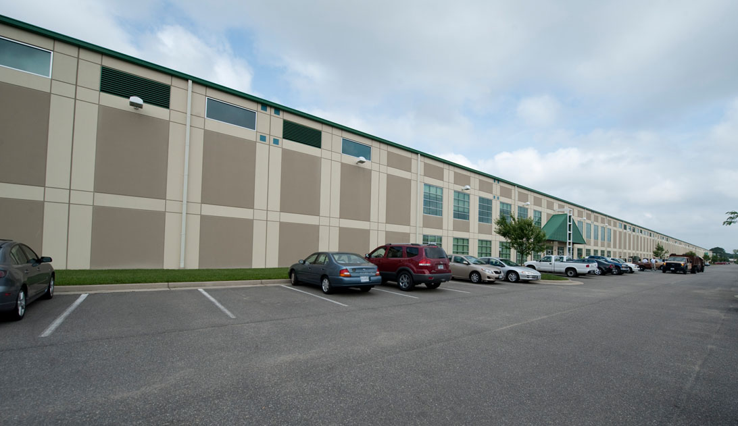

**I – Other Delivery Locations:**

NNS has numerous delivery locations that can be used although Main Receiving is where the bulk of material is delivered. The PO may include identification of these locations. Also the Lane Balance system has a drop down for you to identify these locations when setting up your delivery.

**J – Driver Requirements:**

Driver for deliveries within the main NNS facility via VIS gate or other gate must comply with the following access requirements:

* Drivers must be U.S. citizens; foreign nationals will not be permitted to enter the shipyard
* Drivers must have a picture ID

One day prior to requested access a letter must be received by the NNS Traffic Office with the following requirements:

* Must be typed on trucking company’s letterhead.
* Show the driver’s complete name as it appears on a State License or US Passport
* Include a statement verifying that the driver is a United States citizen

All trucks should have a company name on the side of the truck.

Rental trucks are not allowed.

Hand delivery of the letter by the driver is not acceptable.

The letter must be emailed or faxed to the NNS Traffic Office using the email and/or fax number at the beginning of this document at least one day prior to requested access.

Each driver or individual in the truck must have a letter with the requested information.

This letterhead is not required when delivering to locations outside the main facility including our Main Receiving location at 2175 Aluminum Ave, Hampton, VA.

For drivers that deliver frequently a NNS badge may be granted. This would take the place of the letter noted above. Contact the Traffic Office for details.

**K- Directions to Main Receiving:**

A recording giving directions to the NNS Main Receiving can be heard by calling **(757) 380-3030**.

***From Richmond:***

Proceed on **I-64 East** to **Exit 264 (I-664 Downtown Newport News)** bear right, proceed on **I-664 South, Downtown Newport News**, 2 miles approx. to **Exit 3 – Aberdeen Rd. exit**, turn right at the bottom of the ramp and go approx. ¼ mile to the first red light. Turn left onto Aluminum Ave. go approx. ½ to the third entrance on the left. Turn left into 2175 Aluminum Ave.

***From Norfolk:***

Proceed on **I-64 West to Exit 264 (I-664 Downtown Newport News)** bear right, proceed on **I-664 North, Downtown Newport News**, 2 miles approx. to **Exit 3 – Aberdeen Rd. exit**, turn right at the bottom of the ramp and go approx. ¼ mile to the first red light. Turn left onto Aluminum Ave. go approx. ½ to the third entrance on the left. Turn left into 2175 Aluminum Ave.

**L – Directions to the VIS Gate – Primary Main Facility Access Point**

***From Richmond:***

Proceed on **I-64 East** to **Exit 264 (I-664 Downtown Newport News)** bear right, proceed on **I-664 South, Downtown Newport News**, 4 miles approx. to **Exit 5 - 35th Street exit**, bear right, proceed approx. 1/4 mile to **Warwick Blvd**., bear right to end of ramp which exits on **Warwick Blvd. and 36th Street** - proceed on Warwick Blvd. to Mercury Blvd. overpass. Get into the left-hand turn lane. Once you pass under the overpass turn left following the signs for the James River Bridge. Take the ramp to Mercury Blvd. and immediately get into the left lane. At the first red light turn left onto River Road, continue on River Road until it splits with Shipyard Drive to the Right. Stay to the right onto Shipyard Drive.

***From Norfolk:***

Proceed on **I-64 West to Exit 264 (I-664 Downtown Newport News)** bear right, proceed on **I-664 North, Downtown Newport News**, 4 miles approx. to **Exit 5 - 35th Street exit**, bear right, proceed approx. 1/4 mile to **Warwick Blvd**., bear right to end of ramp which exits on **Warwick Blvd. and 36th Street** - proceed on Warwick Blvd. to Mercury Blvd. overpass. Get into the left-hand turn lane. Once you pass under the overpass turn left following the signs for the James River Bridge. Take the ramp to Mercury Blvd. and immediately get into the left lane. At the first red light turn left onto River Road, continue on River Road until it splits with Shipyard Drive to the Right. Stay to the right onto Shipyard Drive.

**M – Prohibited Items within NNS facilities**

Given the nature of NNS’s business we have very stringent Security requirements. That includes the prohibition of certain items when entering the NNS facilities. These include:

* Cameras
* Camera Phones
* iPad’s/tablets with Cameras
* Weapons of any kind including firearms, guns, and knives
* Drugs
* Alcohol
* Laptops (unless permanently attached to the vehicle)
* Passengers (unless other driver)
* Pets – For a fee, VCA James River Animal Hospital (757-595-5505) at 9804 Warwick Blvd. Newport News will hold pets.

NNS personnel cannot hold/store these items for the driver.

**N – Driver Personal Protective Equipment:**

If the driver is participating in the unloading of the truck they must bring and wear the following PPE (Personal Protective Equipment):

* Hard hat
* Safety glasses
* Steel toed safety shoes.

**O – Freight Invoices:**

All freight invoices should be sent to:

Newport News Shipbuilding

C/O Traffic Consultants Inc.

3875 South Mendenhall Road

Memphis, TN. 38115