Lane Balance Systems

TMS User Guide

For

NNS Carriers

Newport News Shipbuilding

[](http://www.hii-homeport.com/hii/logos/nns_color_linetag.jpg)

**Table of Contents**

1. **TMS Overview_________________________________________________ pg.3**
2. **System Sign On_________________________________________________ pg.4**
3. **Search Shipment________________________________________________ pg.7**
4. **Reports_______________________________________________________ pg.8**
5. **Carrier 214____________________________________________________ pg.10**

##### 

##### TMS Overview

In a practical and detailed manner, the Lane Balance Systems Transportation Management System (TMS) addresses the fundamentals of the inbound and outbound shipment lifecycle. Designed for a multifaceted shipping environment, the system manages simple to complex scenarios involving multiple carriers, transportation modes, and PO/item numbers. Truckload (TL), less-than truckload (LTL) and Intermodal (IML) are supported by a single, centralized application. Many changes/additions have been made to the system to simplify managing shipments for our customers. This manual will help you to get familiar with our TMS. This manual will help you to get familiar with our TMS. This system does not cover FedEx and UPS shipments. Every page of our TMS has a menu across the top of the screen with 5 tabs.

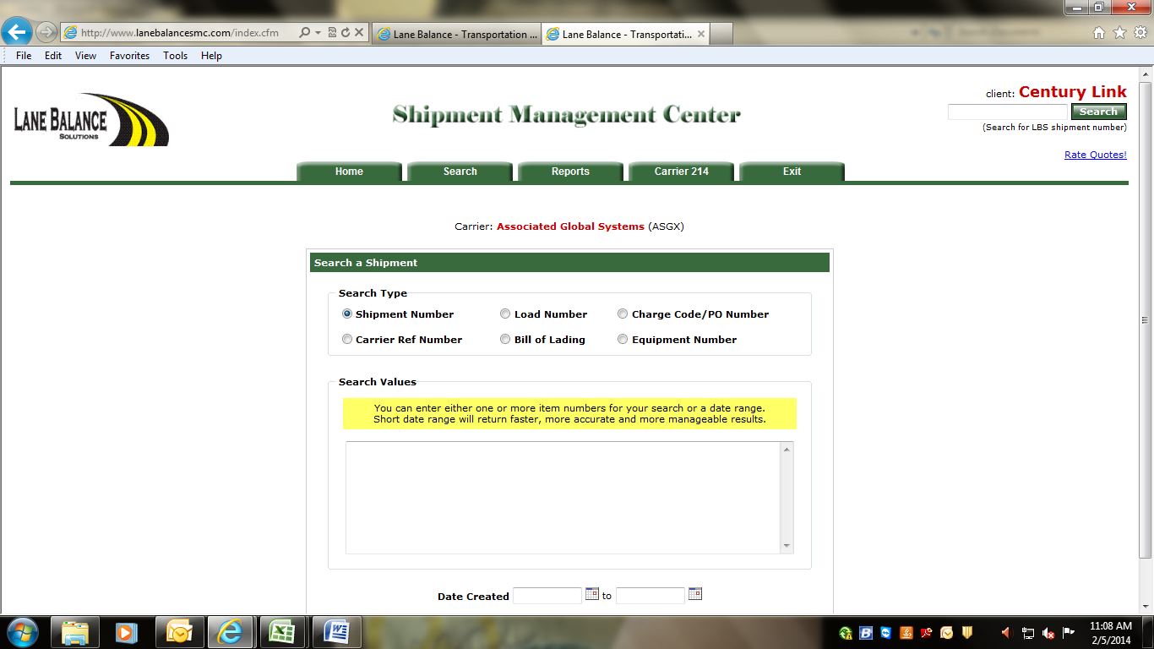

**Home** – The home tab takes you to the home page.

**Search** – The search tab lets you perform a shipment search by various categories.

**Reports** – The reports tab allows you to run a manifest report.

**Carrier 214 –** This tab shows all shipments assigned to the specific carrier.

**Exit** – The exit tab lets you sign off and exit the system.

**System Sign - On**

All authorized users will access the Lane Balance Systems website by going to [www.lanebalancesmc.com](http://www.lanebalancesmc.com)

Once there, the user will need to enter a username and password and then click “Submit” or “Clear” to clear fields.

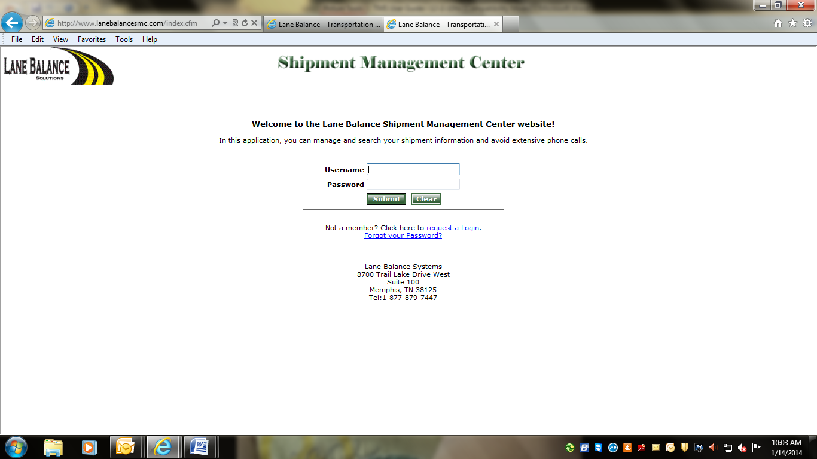

If the user does not have a username and password, he/she will need to request one by clicking the “request a login” option.

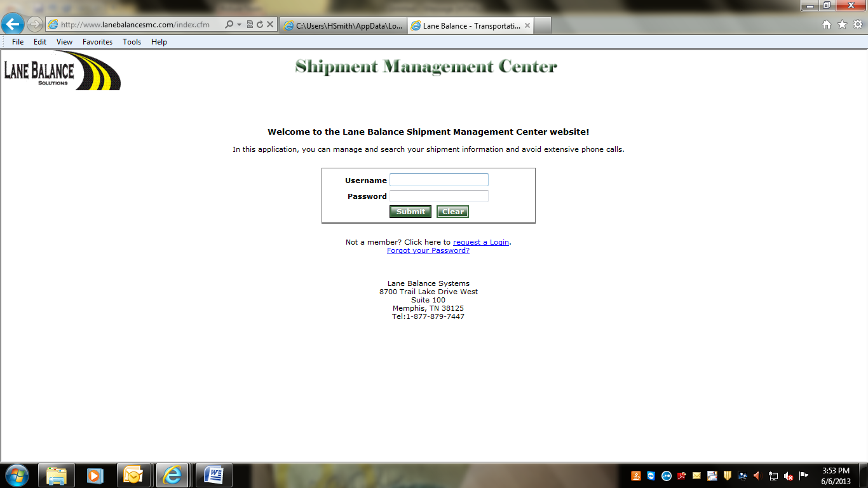

The user will fill out the following information and click on “request new login”. Once the requested information is entered, Lane Balance Systems (LBS) will be contacted immediately. We will grant the authorized user access to the TMS.

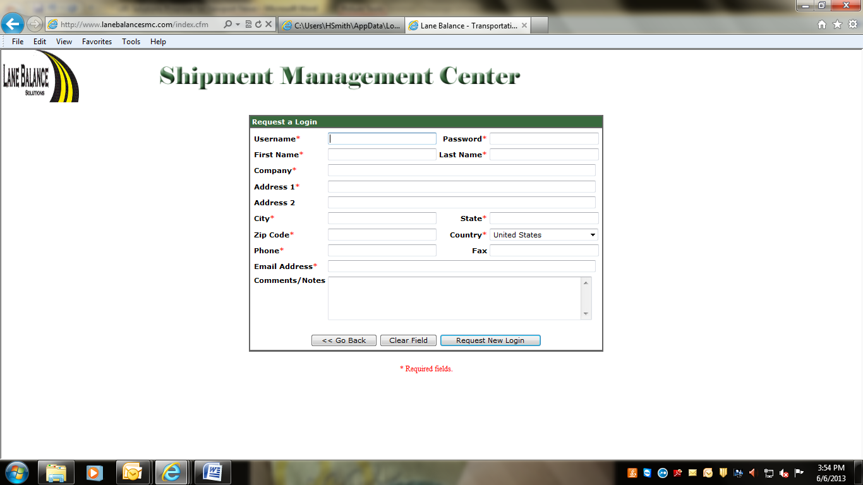

**Search Shipment**

Once the user has successfully logged in, the first screen to appear will be the search menu. This menu provides search capability on shipment numbers (AA#), carrier reference numbers, load numbers, bill of lading numbers, PO & item numbers/charge to codes and part numbers. Select the type of number to search and enter the number in the blank field provided. If searching multiple shipments, enter the data separated by a coma. Once all data is entered, click “Search Shipment”. Shipments can also be searched by date range.

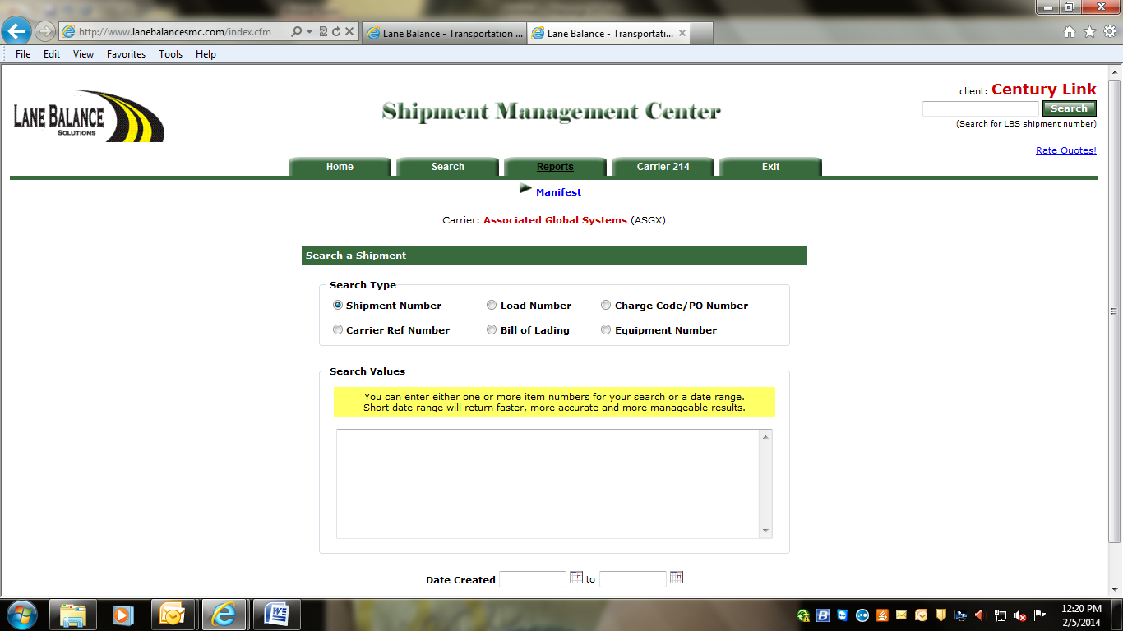

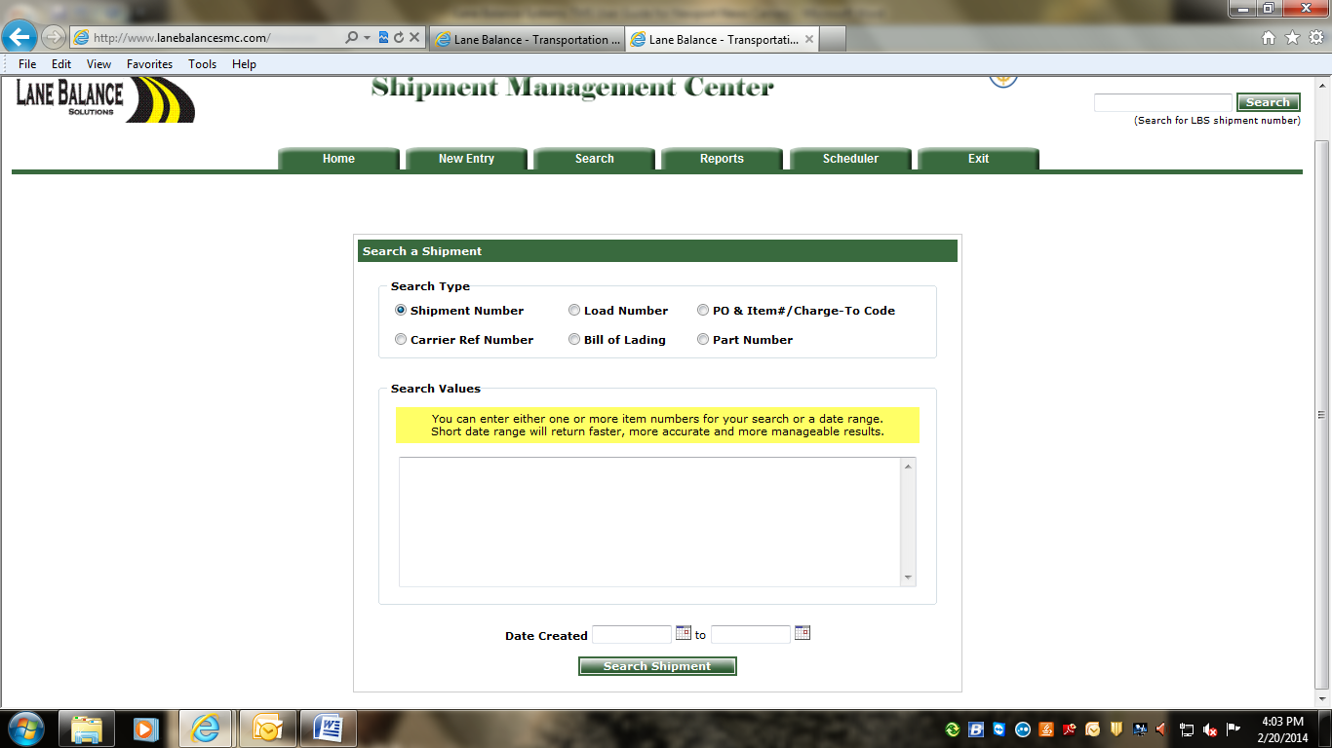

**Reports**

Click on reports and then choose the manifest report.

**Manifest Report -** This report will show all outbound shipments from a specific pickup location and/or all inbound shipments to a specific delivery location.



Select the pickup/delivery location company you want to run a manifest report for, from the drop down list. Once the location has been chosen, select the date range and click “Get Report.”



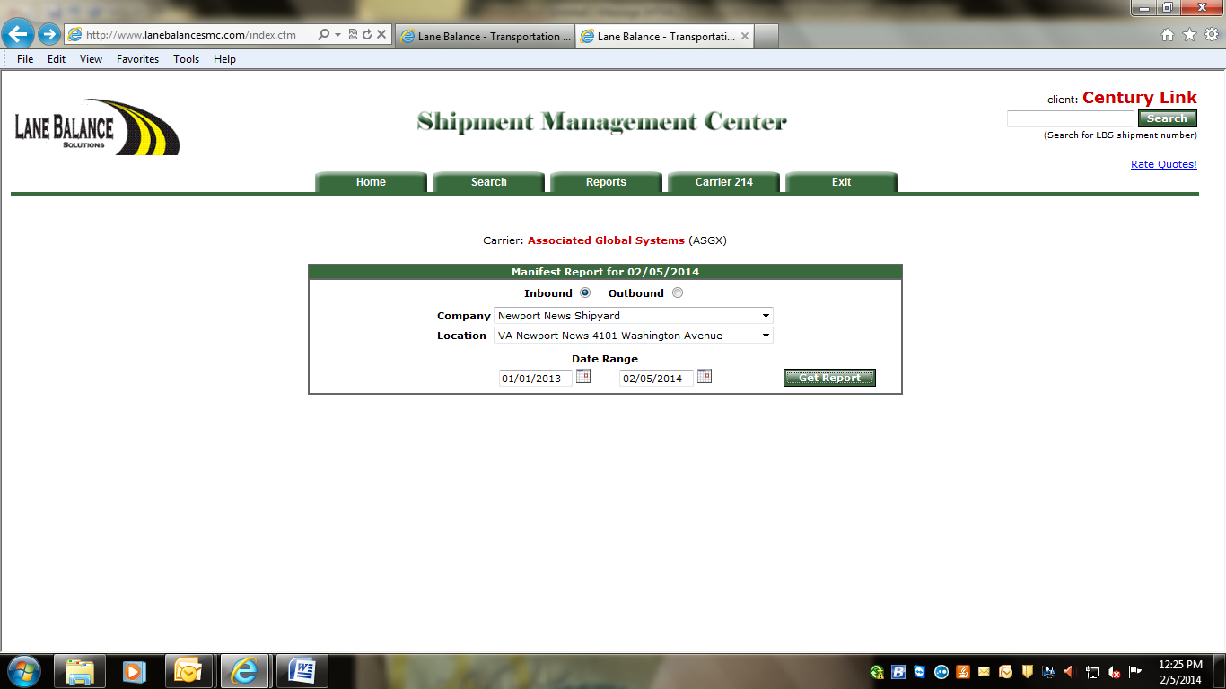

Our system will then display all shipments with the specifications you chose. The user has the choice of exporting the details to Excel by clicking the Export to Excel button.



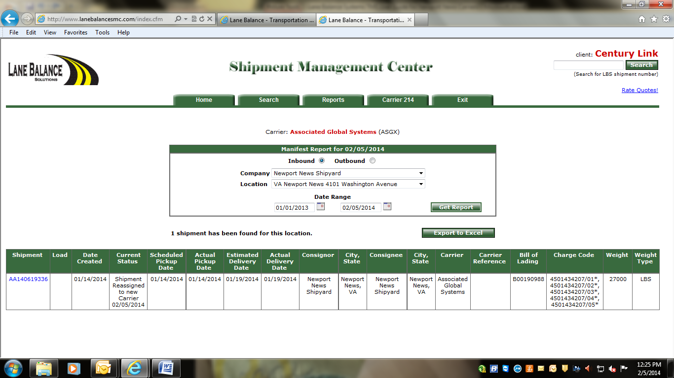

**Carrier 214**

Carriers that prefer to send their shipment status messages electronically please contact Lane Balance and we can work with your IT department to start the EDI process.

Carriers that don’t have EDI capability or don’t have the volume to send their shipment status messages EDI can manually update shipment status messages for their shipments. The Carrier will click on the Carrier 214 tab to view all shipments that have been assigned to them. They can access their assigned shipments in one convenient location. They can enter their tracking numbers and status messages for all their shipments as well as review new shipments for the day to make sure shipments are not missed. The carrier can also export all shipments to an Excel spreadsheet.



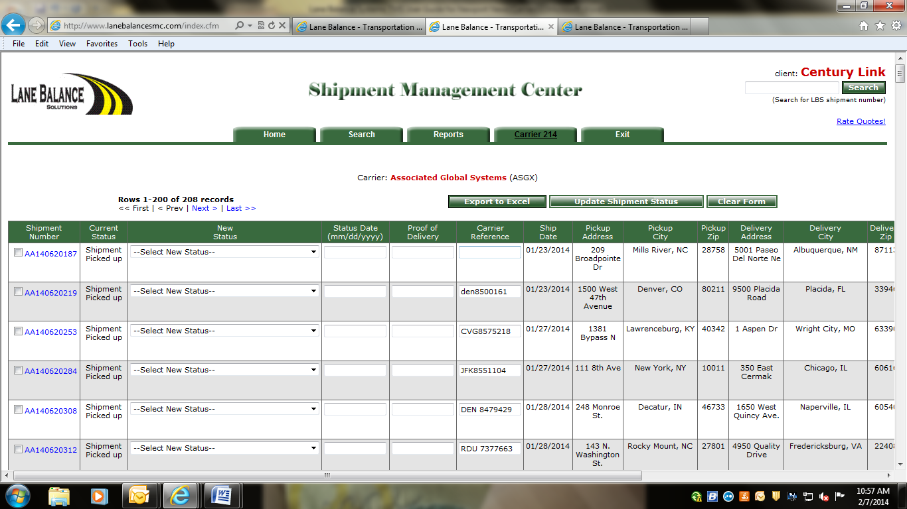

To add the carrier tracking number, the user will find the shipment by looking in the Shipment Number column. Once the shipment has been found, the user can enter their tracking number in the Carrier Reference field.



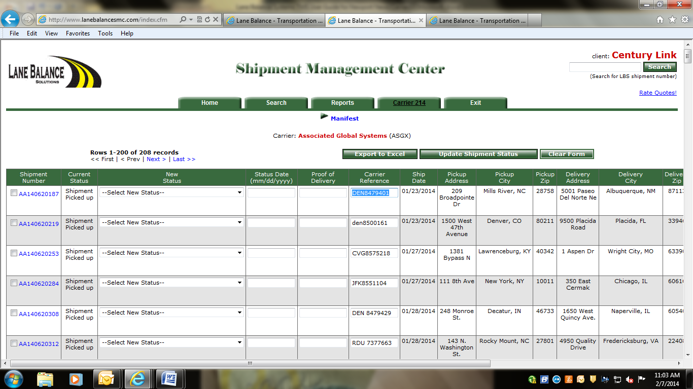

To add the status messages for their shipments, the user will select the appropriate status from the drop down box.



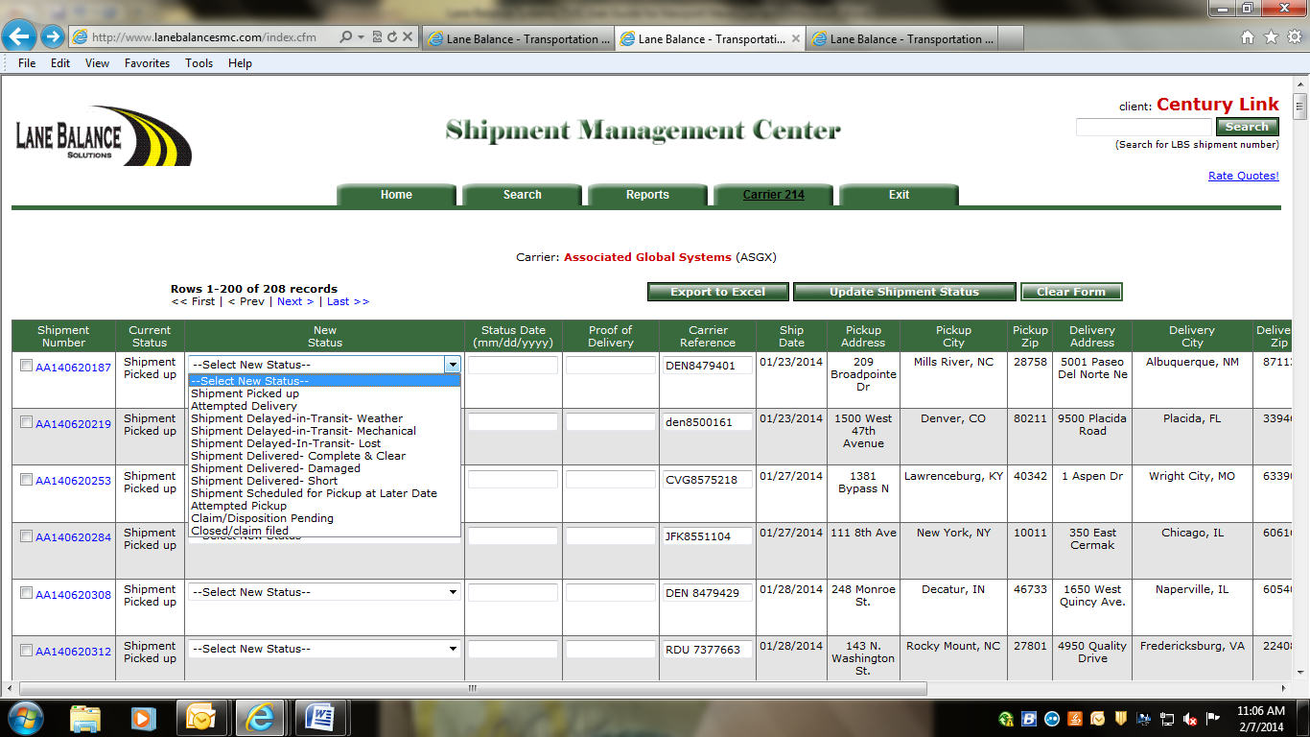

Once the appropriate status message has been selected, the user will enter the status date and click on “Update Shipment Status.”



