NNS – Exostar FAQ Guide

General Overview

* What is NNS? Newport News Shipbuilding, a Division of Huntington Ingalls Industries, hereinafter referred to as NNS.
* What is Exostar? Exostar is a leading provider of secure collaboration solutions and business process integration. In 2011, Exostar won the NNS proposal to replace the Northrop Grumman OASIS functionality in their supply chain and information manager applications due to the separation of NNS from Northrop Grumman.
* Why are NNS and Northrop Grumman requiring dual factor authentication to access their supplier systems? To ensure ITAR controlled information is only accessed by approved personnel who must validate citizenship and location to acquire their second factor identity.
* What is OASIS? OASIS stands for Online Automated Supplier Information Systems and is a custom written application by Northrop Grumman to communicate with its suppliers. ***NNS no longer uses the OASIS system, as it was replaced with Exostar.***

NNS Buyer Specific Information

* What are each buyer’s responsibilities in this program? During the initial rollout of the program, Buyers will provide information and support to their suppliers.   Exostar has developed a Buyer specific [website](http://www2.exostar.com/l/4632/2010-11-19/3L7H).  This site provides details on the project and its requirements, as well as an avenue for Buyers to field questions from Suppliers and provide reassurance and guidance during the process.   Buyers are also an escalation point for non-responding suppliers and will be solicited to encourage suppliers to enroll.
* What if one of my NNS suppliers refuses to purchase a certificate? Doing business with NNS electronically is not mandatory, however highly suggested. NNS may elect to contact that supplier and advise them of the ramifications (delayed PO’s, RFQ’s, etc).
* As a NNS buyer, will I require a token? PO’s, PO Modifications, and RFQ’s do not require the use of a token since they will be integrated with SAP. However; if you use the File Drop capability you will require the same Medium Level of Assurance hardware based tokens to communicate with your suppliers.
* What do I tell Suppliers who don’t understand this? If you have a supplier who requires additional information, please refer them to the Exostar webcast.  Once they have reviewed all of the information provided on the Supplier website, including the webcast, they should contact Exostar’s customer service with any additional questions.
* Are there changes I’ll have to make in the way I do business? The primary responsibility of the Buyer is to ensure all suppliers obtain a digital certificate before they start working with NNS.

Supplier Specific Information

* How will this benefit my business or program? If your business does not sign up it will require the buyer to revert to using fax and US mail to send RFQs, PO’s, etc. This can create delays in the process as these documents cannot be e-mailed. Also, the digital certificate effort will increase the level of assurance across both Newport News Shipbuilding and Northrop Grumman’s entire supply base – eliminating the “weak links” otherwise inherent in supply chain transactions.
* What are each supplier’s responsibilities in this program? Exostar has developed a Supplier specific [website](http://www2.exostar.com/l/4632/2010-11-19/3KCN).  This site provides details on the project and its requirements.  Suppliers are responsible for seeing the process through from beginning to end and ensuring that each applicable individual has a hardware-based digital certificate installed. This certificate is required by both NNS and Northrop Grumman.
* Will these responsibilities change? Suppliers will be responsible for the renewal of their digital certificate, every 1 or 3 years depending on the purchase option chosen.  Additionally, if the token is lost or stolen it is the Suppliers responsibility to replace the token and certificate at full price.
* How often do I have to do through the proofing process? Anyone holding an Exostar token will have to get re-proofed every 9 years.

Exostar Responsibilities

* What are Exostar’s responsibilities in the token/certificate process? Exostar is responsible for the issuance and delivery of the hardware-based digital certificate to each Newport News and/or Northrop Grumman supplier.  Questions related to digital certificates, including pricing, delivery, in-person proofing, etc should be directed to Exostar.

NNS Responsibilities

* What are NNS’s responsibilities? NNS has selected Exostar as the replacement for the electronic procurement application to communicate with suppliers. NNS will also require hardware-based digital certificates.  NNS has established the requirement for the issuance of these certificates.  NNS will be responsible for all questions related to the requirement for these certificates and all application related questions, such as those concerning Exostar’s Supply Chain Platform and Information Manager applications.
* What is NNS NOT responsible for? NNS will not be able to address any questions relating to the installation, proofing, certificate related issues, or technical issues with the Exostar Application.

Contact Information

* Where can I obtain more information on the program? There are two project site available to assist you:
  + <http://www2.exostar.com/l/4632/2010-11-19/3L7H> provides information specifically for the buyers
  + <http://www2.exostar.com/l/4632/2010-11-19/3KCN> provides information specifically for the suppliers
  + You may also send questions to [Exostar@hii-nns.com](mailto:Exostar@hii-nns.com) and they will be answered by the Exostar administrator.

Timing/Timeline

* How long will it take to get my digital certificates? Once a digital certificate has been purchased, it typically takes up to two weeks to complete the in-person proofing and installation process.  Remember to have your documentation ready and to not miss your proofing appointment.

The Process for Suppliers

* What will my Suppliers receive from Exostar? Exostar has launched a marketing campaign to inform suppliers of this program.  Once a supplier has purchased a certificate, they will receive information about how to complete the proofing process, prepare their system, and receive the certificate.

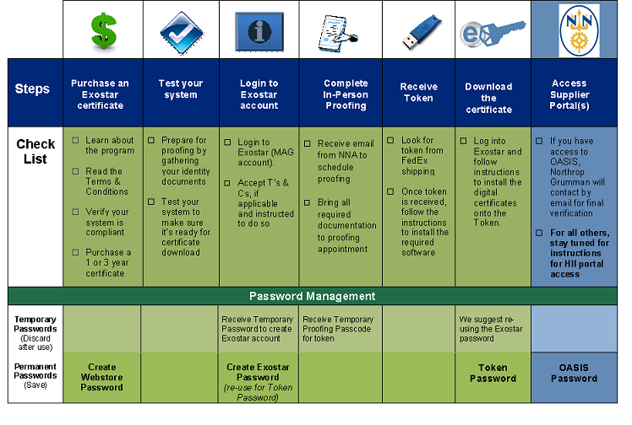

* How much does it cost? Digital certificates come in one and three year options.  Exostar has a special rate for NNS suppliers of $280/one year and $385/three year.
* How much does it cost to renew? How does it work? Renewals are also in one year or three year options, depending on the choice selected initially. As long as the supplier keeps their token, the only charge they will occur is for the digital certificate. The one year digital certificate price for renewal is $70; and the three year price is $210. Exostar will notify the user with an email reminder 30 days, 15 days, and 3 days prior to the expiration.
* What does “in person” proofing entail? In-person proofing is when Exostar Trusted Agents (Notaries) personally meet with the supplier and review their identifiable documentation.
* Once the “in person” proofing is complete, how quickly do I need to complete the process? Once you have been proofed, you have 30 days to download your certificate onto the token. If this is not done within 30 days you will have to complete the entire process over again including payment. Do not wait until the last minute to download your certificate in case there are technical issues you need to work through.
* Can the token be used by multiple people in my company? No, the certificate and token are unique to the individual. That individual certifies that they will be the only person using the digital certificate on the token.
* Will I be kept up to date along this process? You will be kept informed if/when there are problems with the process.

Supplier Campaign Documents “Credential Kits”

* What is a credential kit? A credential kit is the set of materials the supplier will have access to when enrolling for the digital certificate.  Information will be provided via a website, email, and webcasts.
* Where do they go for questions? The suppliers can go to <http://www2.exostar.com/l/4632/2010-11-19/3KCN>  for information
* **For Exostar questions, please contact the Exostar Help Desk Hotline**   
  **Phone:** 703-793-7800   
  **Web**: <http://www.myexostar.com/contactSupport.aspx>   
  **Email:** [CustomerService@Exostar.com](mailto:CustomerService@Exostar.com)